**Chapter 1**

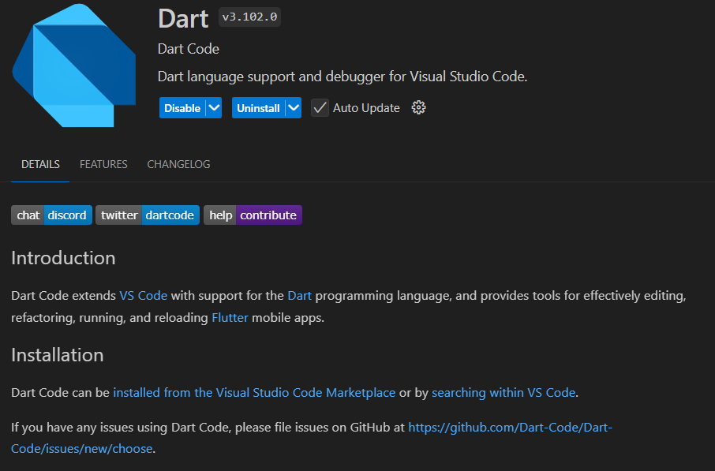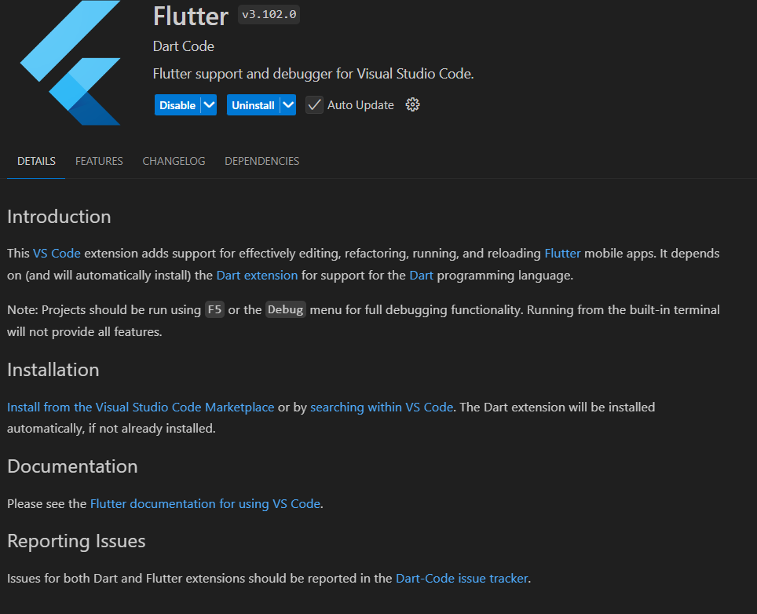To set up Flutter with Dart in Visual Studio Code, begin by downloading the Flutter SDK from its official website and extracting it to a directory of your choice. Add the flutter/bin directory to your system’s PATH to access Flutter commands globally. Install Visual Studio Code and enhance it by adding the Flutter and Dart extensions from the Extensions Marketplace to enable Flutter development features. For Android development, install Android Studio, configure the Android SDK, and set up a virtual device using the AVD Manager. If you’re on macOS and developing for iOS, install Xcode and complete its configuration. In VS Code, create a new Flutter project through the Command Palette and connect a physical device or launch an emulator for testing. Open the main.dart file in the project and run your app using the play button or F5. Use the flutter doctor command to check if all dependencies are installed correctly. Following these steps ensures a seamless setup, allowing you to start building Flutter apps efficiently.